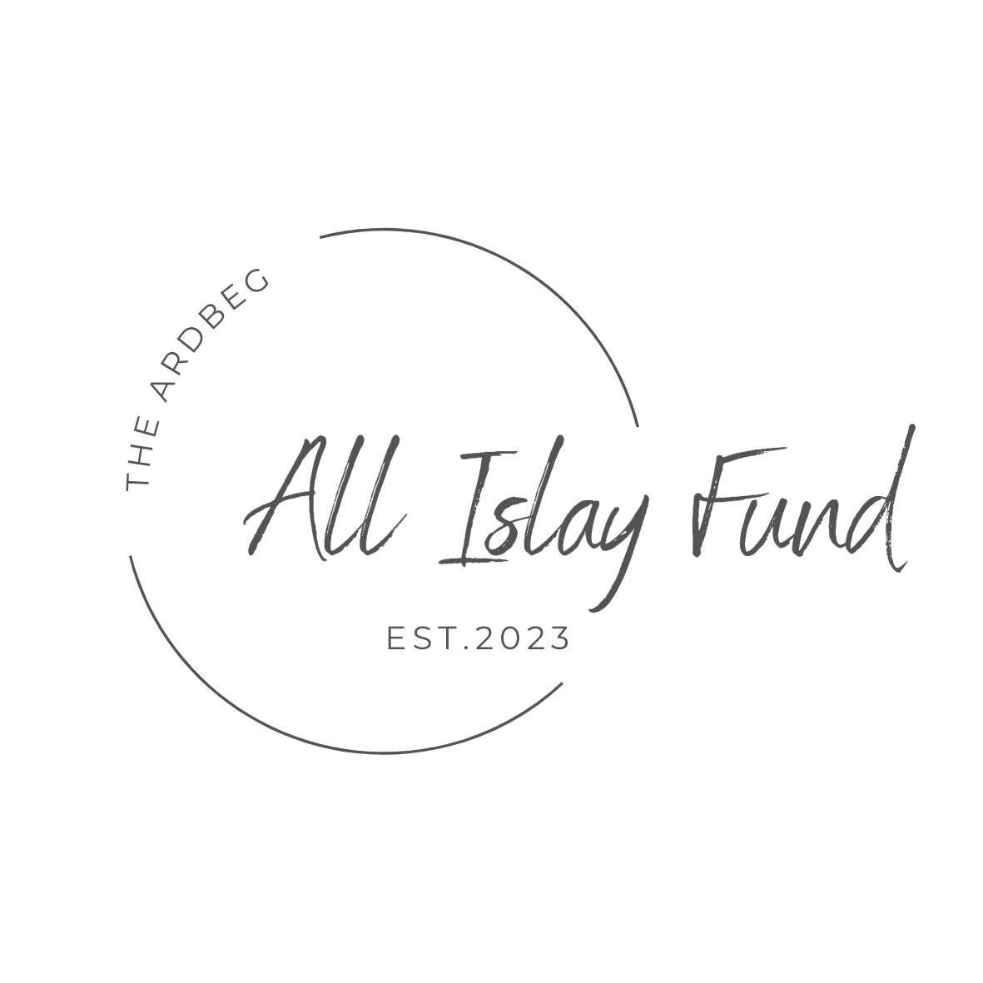

Application Form
2024

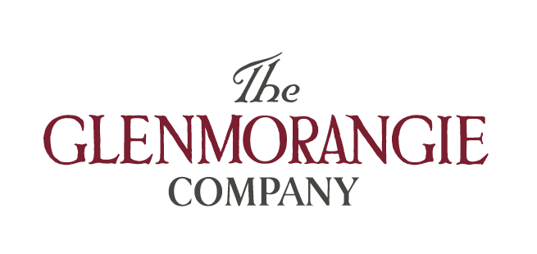

An Introduction to The Ardbeg All Islay Fund

Background

South Islay Development (SID), a local development company based in Islay, is delighted to be working in partnership with Ardbeg Distillery and The Glenmorangie Company to identify and fund projects the length and breadth of Islay over the next 5 years. A £1 million fund, THE ARDBEG ALL ISLAY FUND, has been established following the sale of a rare Ardbeg 1975 cask of single malt whisky sold to a private investor for £16m in 2022.

The distillery’s donation aims to celebrate this success and support community and environmental projects on Islay. SID and Ardbeg are no strangers to community projects and have nurtured a working relationship in the south of Islay, sharing similar values. The fund will enable exciting, creative, and dynamic projects to get off the ground, grow, prosper, become sustainable and make an overall impact on the long-term future of Islay.

Aims and Aspirations

- The fund will benefit organisations, projects, and enterprising activities across the whole of Islay.
- Building sustainable community groups for all ages within our community.
- Encouraging groups to use The Ardbeg All Islay Fund as match funding with other funders.
- Or for ‘top up’ funding to accelerate projects that already have main support funding in place and planning/regulatory bodies.

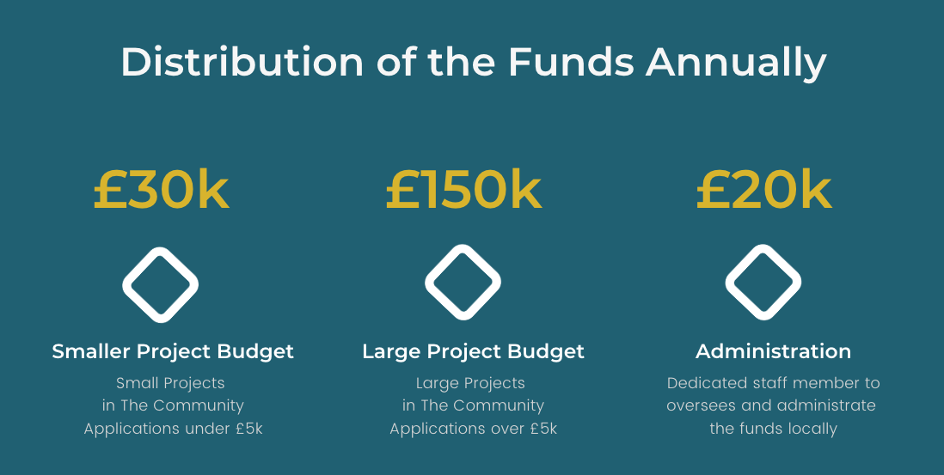

The Ardbeg All Islay Fund has three funding priorities –

- Supporting Active Lives: ensuring access to a range of physical and healthy activities;
- Building Community Resilience: helping residents access learning and training, supporting carers to access external services or supporting local cultural activities and facilities;
- Enhancing The Environment: establishing or supporting environmental schemes such as CO2 reduction, recycling, or land use, including biodiversity improvements and peatland restoration.
Part One
Check you are eligible to apply

You can apply if your organisation is a:
voluntary or community organisation
registered charity
constituted group or club
not-for-profit company or Community Interest Company
the school (if your project benefits and involves the communities around the school)
statutory body (including faith-based groups or community councils).

We can’t accept applications from:
individuals
sole traders
companies that can pay profits to directors, shareholders, or members (including Companies Limited by Shares)
organisations based outside the Isle of Islay

If you’re a smaller organisation
We’re keen to fund smaller organisations too.

If you’re a school or an organisation working in a school
Make sure your project strengthens the community outside of the school too. So, it should benefit, and involve, more than just teachers, pupils, and parents of pupils.

The kinds of school projects we don’t usually fund:

• projects to improve school facilities or equipment
• projects to help with staff training
• projects that are part of the school curriculum
• projects that involve activities the school should already be providing (like a project teaching literacy during school hours)
• projects that take place during teaching times (lunch breaks, or before and after school might be okay).

If you meet all these requirements – great. You can apply for The Ardbeg All Islay Fund.
We’re excited to hear more about your project and invite you to fill in our application form.

If you’ve checked that you can apply but don’t meet these requirements or are not sure if you can please contact SID. We don’t want communities to miss out on a great idea that can help them flourish so groups or organisations are welcome to discuss their project/idea with our Development Manager, Alyson, if in doubt.

Before you apply, check the boxes below to confirm:

Your organisation has at least two people on the board or committee who aren’t married, in a relationship, living together at the same address, or related by blood.

You’re applying for an amount between £500 and £50,000 for a project that’ll be finished in around 12 months. We also consider applications for one-off events such as a festival, gala or conference).

You have a UK bank account or building society in the legal name of your organisation, with at least two unrelated people who can manage the account. This should be the legal name of your organisation as it appears on your bank statement, not the name of your bank. This will usually be the same as your organisation’s name on your governing document. Please submit your latest statement.

You produce annual accounts (or you set up your organisation less than 15 months ago and haven’t produced annual accounts yet). By annual accounts, we mean a summary of your financial activity. If you’re a small organisation, this might be produced by your board and doesn’t have to be done by an accountant. Please submit your latest accounts.

Your organisation can complete and return a mid or end of-term report depending on the grant amount requested.

The Application Timescale

.

Applications received after the closing date will not be considered.
Please email the completed application form to southislaydevelopment@gmail.com
You will receive an acknowledgement email shortly after receipt.

Please contact Alyson MacGillivray at South Islay Development if you have any questions.
Email: southislaydevelopment@gmail.com or call: 01496 300 579

Please indicate which funding grant bracket you would like to apply for: -

A Grant under £5,000

A Grant over £5,000 but no more than £50,000

Part Two
Your Organisation

Organisation details (Step 1 of 4)

What is the full legal name of your organisation?
This must be as shown on your governing document. Your governing document could be called one of several things, depending on the type of organisation you're applying on behalf of. It may be called a constitution, trust deed, memorandum and articles of association, or something else entirely.

When was your organisation set up?

Please tell us the month and year. For example, 11 2017

What is the main or registered address of your organisation?
Building and or Street
Address line 2 (Optional)
Town or city
County (Optional)
Postcode

Organisation type (Step 2 of 4)

What type of organisation are you?

If you’re both a charity and a company just pick a not-for-profit company below: -

Unregistered voluntary or community organisation
Not-for-profit company
Registered charity (unincorporated)
Scottish Charitable Incorporated Organisation (SCIO)
Community Interest Company (CIC)
Company (CIC) Regulator
If you’re a statutory body, tell us what type of statutory body you are: -

Community Council
School
Other

Registration numbers (Step 3 of 4)

If you have any reference or registration numbers, tell us what they are:

Charity Registration number

Companies House number

Organisation finances (Step 4 of 4)

What is your accounting year-end date? (Please submit your latest accounts with your application)

For example: - 31 03

Latest Accounting Year End Turnover

Current Unrestricted Reserves

Part Three
Your Senior Contact

Please give us the contact details of a senior member of your organisation.

This person is usually a senior leader or a member of your board or committee.

Your senior contact must be at least 18 years old and is legally responsible for ensuring that this application is supported by the organisation applying, any funding is delivered as set out in the application form, and that the funded organisation meets our monitoring requirements.

Role

Your senior contact must hold one of the following positions. The role of the senior contact depends on what type of organisation you are. Tick the relevant box.

Registered charity/voluntary or community group - Trustee, Chair, Vice Chair, Secretary, Treasurer
Charitable incorporated organisation - Trustee, Chief Executive Officer
Not-for-profit company or Community Interest Company (CIC) - Company Director, Company Secretary
School - Head Teacher, Parent Council Chair, Secretary

What is the name and address of your senior contact?
Full name
Building and street
Address line 2 (Optional)
Town or city
County (Optional)
Postcode

Email
We’ll use this whenever we get in touch about the project.

Telephone number

Part Four
Your Main Contact

Please give us the contact details of a person we can get in touch with if we have any questions. The main contact is usually the person filling in the form – so it’s probably you.
The main contact needs to be from the organisation applying, but they don’t need to hold a particular position.
The main contact must be a different person from the senior contact and the two contacts also can’t be:

- married to each other
- in a long-term relationship together
- living at the same address
- or related by blood.

What is the name and address of your senior contact?
Full name
Building and street
Address line 2 (Optional)
Town or city
County (Optional)
Postcode

Email
We’ll use this whenever we get in touch about the project.

Telephone number

Part Five
Bank Details

We need your bank details to pay the funding into your account – if your application is successful.

Tell us the name of your organisation – as it appears on your submitted bank statement.

Sort Code
E.g., 12-34-56

Account Number
For e.g., 12345678

Part Six
Your Project

Project Details (Step 1 of 3)

What is the name of your project?

The project name should be simple and to the point.

Provide a summary of your project.

This should be simple and to the point. (You can write up to 100 words.)

When would you like to start and end your project?
If you don’t know exactly, your dates can be estimates.

Start Date
Day Month Year

End Date
Day Month Year

Where will your project be based in Islay?

If your project covers more than one community, tell us which areas on Islay.

Project Idea (Step 2 of 3)

What would you like to do?

Here are some ideas of what to tell us about your project:
- What you would like to do.
- What difference your project will make.
- Who will benefit from it.
- How long do you expect to run it for? This can be an estimate.
- How you’ll make sure people know about it.
- How you plan to learn from it and use this learning to shape future projects.
- Is it something new, or are you continuing something that has worked well previously?
We can fund both new and existing projects.

You can write up to 500 words for applications for under £5k and 1000 words for over £5k.

How does your project meet at least one of our funding priorities?

The Ardbeg All Islay Fund has three funding priorities, please tell us how your project will meet at least one of these.

- Supporting Active Lives: ensuring access to a range of physical and healthy activities;
- Building Community Resilience: helping residents access learning and training, supporting carers to access external services or supporting local cultural activities and facilities;
- Enhancing The Environment: establishing or supporting environmental schemes such as CO2 reduction, recycling, or land use, including biodiversity improvements and peatland restoration.
You can tell us if your project meets more than one priority, but don't worry if it doesn't.

You can write up to 500 words for applications for under £5k and 1000 words for over £5k.

How does your project involve your community?

We believe that people understand what's needed in their communities better than anyone. Tell us how your community came up with the idea for your project. We want to know how many people you've spoken to, and how they'll be involved in the development and delivery of the project.

Here are some examples of how you could be involving your community:
- having regular chats with community members, in person or on social media
- including community members on your board or committee
- regular surveys
- setting up steering groups
- running open days.
You can write up to 200 words for this section.

Project costs (Step 3 of 3)

Tell us the TOTAL cost of your project

This is the cost of everything related to your project, even things you aren't asking us to fund.

For example, What is the total cost for the project to go ahead?, this should include:- your request amount to All Islay Fund, any secured/unsecured funding and in-kind support.
£

(You will be asked to break this down on the next page.)

Have you secured any other funding e.g., match funding or additional funding to allocate to this project from the public or private sector? (If so, please provide details below) Yes No

Sources of Other Funding
Funding source/partner | Amount | Secured/Awaiting
 | £
 | £
Total | £

List the costs you would like us to fund

You should use budget headings, rather than a detailed list of items. For example, if you're applying for pens, pencils, paper and envelopes, using office supplies is fine.

Item or Activity | Amount
Example: office supplies | £250
 | £
 | £
 | £
 | £
 | £
Total cost you’d like us to fund (Must fit with your answer on page 3)

Part Seven
Your Declaration

Please read this section carefully and make sure you understand it all, especially our terms and conditions.

Data Protection

Applicants to The Ardbeg All Islay Fund should be aware that SID is subject to the provisions of the Freedom of Information (Scotland) Act 2002, the Environmental Information (Scotland) Regulations 2004 and the Data Protection Act 1998.

Please, therefore, note that information provided, including personal information, will be held, published, and disclosed by this legislation. When applying, please let us know if there were any parts of it which would prejudice your commercial or other interests if they were made public. However, given our obligations, please note we cannot guarantee confidentiality.

We may share your personal data with organisations that help us with our grant-making activities or others that have a legitimate interest in our work or have funded your grant. We will only share personal data that they need to carry out their work and subject to appropriate safety measures.

We may keep in contact with you throughout the life of your grant and send you advice about your grant by email. This will contain useful information on a range of things including how to publicise your grant, information on other funding available and project ideas and tips from other grant holders.

Our data protection and privacy notice gives more information about how we store and use personal data and the lawful basis for this. Please contact us to request a hard copy. The notice may be updated from time to time.

Freedom of Information

The Freedom of Information Act 2000 gives members of the public the right to request any information that we hold. This includes information received from third parties, such as, although not limited to grant applicants, grant holders and contractors.

If you think that there is information in your application that may be exempt from release if requested, then you should let us know when you apply. We will not usually release information about your project whilst it is being assessed. Otherwise, we will use our judgement as to whether any exemptions may apply, which we may seek your opinion on. Personal information would be withheld subject to the requirements of data protection laws.

Copies of South Islay Development Policies are available on request.

By signing this you are confirming that you are an authorised signatory for the organisation applying for The Ardbeg All Islay Fund. You are also confirming that the statement below is accurate.

As far as I know and believe, the information in this application form about the project is true and accurate. I am authorised to allow this project to go ahead and include the relevant documentation as requested. I confirm that South Islay Development can:

- share any details they have about our project from this application or future assessments to colleagues and other agencies, including other grant-making bodies; and
- use any of the project details in news releases, publications, and other publicity materials.

South Islay Development can do these things without asking us again for our agreement and will not use any of these details for commercial purposes. I agree: -

You have been authorised by the governing body of your organisation (the board or committee that you or your organisation) to submit this application.

All the information you have provided in your application is accurate and complete, and you will notify us of any changes.

You understand that we will use any personal information you have provided for the purposes described under the Data Protection Statement above.

If information about this application is requested under the Freedom of Information Act, we will release it in line with our Freedom of Information Policy above.

If your application was successful, would your group need support to implement
your project if this was available through South Islay Development? Yes No

Full name of person completing this form

Position in organisation

Date Signed

Part eight
Send us your Application

Before sending us your application

Check the boxes below to confirm you have:

Answered all the questions in the form. If you haven’t finished your application, we’ll need to get back in touch with you and it’ll take longer for us to give you funding.

Attached a copy of your organisation’s bank statement, latest charity accounts & constitution – along with a business plan and any relevant documents if required.

Please make sure that we can see the following on your bank statement:

- your organisation’s legal name
- the address the statements are sent to
- the bank name
- account number
- sort code
- date (must be within the last three months).

Your statement needs to be less than three months old.
For bank accounts opened within the last three months, we can accept a bank welcome letter. This must confirm the date your account was opened, account name, account number and sort code.

If you're a school using a local authority bank account
We'll need a letter from the local authority dated within the last three months.
It should show:
- your school name
- the bank account name
- account number
- sort code.

Submitting your application

The closing date for applications is noon on Wednesday 13th March 2024.

Applications received after this time will not be considered.
Please email the completed application form to southislaydevelopment@gmail.com

You will receive an acknowledgement email shortly after receipt.

We aim to notify you regarding the outcome of your application before the end of April 2024.

If you have any questions, please contact Alyson MacGillivray at South Islay Development.
Email: southislaydevelopment@gmail.com or Call: 01496 300 579

